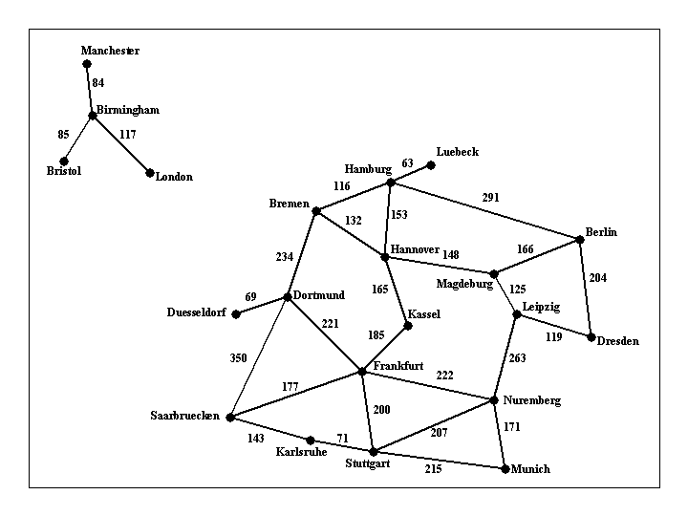  
Figure 1: Visual representation of [input1.txt](http://crystal.uta.edu/~gopikrishnav/classes/2020/spring/4308_5360/assmts/assmt1_files/input1.txt)

Implement a search algorithm that can find a route between any two cities. Your program will be called find_route, and will take exactly commandline arguments as follows:  
  
***find_route input_filename origin_city destination_city*** ***heuristic_filename***  
  
An example command line is:  
  
find_route input1.txt Bremen Kassel (For doing Uninformed search)  
or  
find_route input1.txt Bremen Kassel h_kassel.txt (For doing Informed search)  
  
If heuristic is not provided then program must do uninformed search. Argument input_filename is the name of a text file such as [input1.txt](http://crystal.uta.edu/~gopikrishnav/classes/2020/spring/4308_5360/assmts/assmt1_files/input1.txt), that describes road connections between cities in some part of the world. For example, the road system described by file input1.txt can be visualized in Figure 1 shown above. You can assume that the input file is formatted in the same way as [input1.txt](http://crystal.uta.edu/~gopikrishnav/classes/2020/spring/4308_5360/assmts/assmt1_files/input1.txt): each line contains three items. The last line contains the items "END OF INPUT", and that is how the program can detect that it has reached the end of the file. The other lines of the file contain, in this order, a source city, a destination city, and the length in kilometers of the road connecting directly those two cities. Each city name will be a single word (for example, we will use New_York instead of New York), consisting of upper and lowercase letters and possibly underscores.  
  
**IMPORTANT NOTE**: MULTIPLE INPUT FILES WILL BE USED TO GRADE THE ASSIGNMENT, FILE [input1.txt](http://crystal.uta.edu/~gopikrishnav/classes/2020/spring/4308_5360/assmts/assmt1_files/input1.txt) IS JUST AN EXAMPLE. YOUR CODE SHOULD WORK WITH ANY INPUT FILE FORMATTED AS SPECIFIED ABOVE.  
  
The program will compute a route between the origin city and the destination city, and will print out both the length of the route and the list of all cities that lie on that route. It should also display the number of nodes expanded, nodes generated and max number of nodes in the fringe. For example,  
  
find_route input1.txt Bremen Kassel  
  
should have the following output:  
  
nodes expanded: 12  
nodes generated: 19  
max nodes in memory: 11  
distance: 297.0 km  
route:  
Bremen to Hannover, 132.0 km  
Hannover to Kassel, 165.0 km  
  
and  
  
find_route input1.txt London Kassel  
  
should have the following output:  
  
nodes expanded: 7  
nodes generated: 6  
max nodes in memory: 3  
distance: infinity  
route:  
none  
  
For full credit, you should produce outputs identical in format to the above two examples.  
  
The following part is required for students of CSE 5360 (It is extra credit CSE 4308): If a heuristic file is provided then program must perform Informed search. The heuristic file gives the estimate of what the cost could be to get to the given destination from any start state (note this is just an estimate). In this case the command line would look like  
  
find_route inf input1.txt Munich Kassel h_kassel.txt  
  
Here the last argument contains a text file what has the heuristic values for every state wrt the given destination city (note different destinations will need different heuristic values). For example, you have been provided a sample file [h_kassel.txt](http://crystal.uta.edu/~gopikrishnav/classes/2020/spring/4308_5360/assmts/assmt1_files/h_kassel.txt) which gives the heuristic value for every state (assuming kassel is the goal). Your program should use this information to reduce the number of nodes it ends up expanding. Other than that, the solution returned by the program should be the same as the uninformed version. For example,  
  
find_route input1.txt Bremen Kassel h_kassel.txt  
  
should have the following output:  
  
nodes expanded: 3  
nodes generated: 7  
max nodes in memory: 6  
distance: 297.0 km  
route:  
Bremen to Hannover, 132.0 km  
Hannover to Kassel, 165.0 km